Automatic Irrigation System
By
Shilpan Pawan Singh 20BCE1816
Saptajit Banerjee 20BCE1513
Ansh Goel 20BCE1798

A project report submitted to

Dr. S. Sivakumar

SCHOOL OF ELECTRONICS ENGINEERING

in partial fulfilment of the requirements for the course of

CSE2006 - Microprocessors and Interfacing

In

B. Tech. COMPUTER SCIENCE AND ENGINEERING


Vandalur – Kelambakkam Road
Chennai – 600127
April 2022

BONAFIDE CERTIFICATE
Certified that this project report entitled “Automatic Irrigation System” is a bonafide work of Shilpan Pawan Singh - 20BCE1816, Saptajit Banerjee - 20BCE1513, Ansh Goel - 20BCE1798 who carried out the Project work under my supervision and guidance for CSE2006 -Microprocessors and Interfacing

Dr. S. Sivakumar

Associate Professor

School of Electronics Engineering (SENSE),

VIT University, Chennai

Chennai – 600 127.

Abstract

The project we have undertaken is "Automatic Irrigation System Using Arduino". This project is taken up as India is an agriculture oriented country and the rate at which water resources are depleting is a dangerous threat hence there is a need of smart and efficient way of irrigation. In this project we have implemented sensors which detect the humidity in the soil (agricultural field) and supply water to the field which has water requirement. The project is 8051 microcontroller based design which controls the water supply and the field to be irrigated. There are sensors present in each field which are not activated till water is present on the field. Once the field gets dry sensors sense the requirement of water in the field and send a signal to the microcontroller. Microcontroller then supply water to that particular field which has water requirement till the sensors is deactivated again. In case, when there are more than one signal forA low cost alternative solution for efficient water management currently in use is drip irrigation systems that consist of an automated controller to turn on & off the control values, which in turn helps the farmers by managing the water supply to the crop fields and further maintains the moisture levels of soil that helps in better crop production. This project probes into the design of the automated irrigation system based on Arduino. This Embedded project is to design and develop a low cost feature which is based on embedded platform for water irrigation system. This project uses temperature and soil moisture sensors to detect the water quantity present in agriculture. The project uses Arduino micro controller which is controller to process the information. water requirement then the microcontroller will prioritize the first received signal and irrigate the fields accordingly

The development of the automated irrigation system based on microcontrollers and wireless communication at experimental scale within rural areas is presented. The aim of the implementation was to demonstrate that the automatic irrigation can be used to reduce water use. A microcontroller for data acquisition, and transceiver, the sensor measurements are transmitted to a microcontroller based receiver. This gateway permits the automated activation of irrigation when the threshold values of soil moisture and temperature is reached.

Embedded systems are finding increasing application not only in Domestic applications but also in areas of industrial automation, automobiles, power electronics, defence and space equipment's. Microcontrollers from the basic building blocks for many embedded systems. The project deals with the development of infrared remote controller of home appliances using AT89S51 micro controller, which is used to regulate the power flowing in the AC load using a remote controller sending signals to the micro controller AT89S51 as interrupts. The device is manufactured using Atmel's high-density non-volatile memory technology and is compatible with the industry standards MCS-51 instruction set. By combining a versatile 8-bit CPU with flash on a monolithic chip, the AT89S51 is a powerful micro controller which provides a highly flexible and cost effective solution to many embedded control applications. Other 3-channels are used for ON/OFF type control or for switching devices. The revolution of home networking is an emerging technology in this digital era. Like many other AC drives gets to be automated with the embedded controllers for most of the devices for safety at residential areas or in industries. The project is an attempt to implementation of few consumer electronic products mostly at homes.

ACKNOWLEDGEMENT

We wish to express our sincere thanks and deep sense of gratitude to our project guide, Dr. S. Sivakumar , Associate Professor, School of Electronics Engineering, for her consistent encouragement and valuable guidance offered to us in a pleasant manner throughout the course of the project work.

We are extremely grateful to Dr. Sivasubramanian. A, Dean of School of Electronics Engineering, VIT Chennai, for extending the facilities of the School towards our project and for his unstinting support. We express our thanks to our Head of the Department Dr. Vetrivelan. P for his
support throughout the course of this project.

We also take this opportunity to thank all the faculty of the School for their support and their wisdom imparted to us throughout the course.
We thank our parents, family, and friends for bearing with us throughout the course of our project and for the opportunity they provided us in undergoing this course in such a prestigious institution.

Ansh Goel Saptajit Banerjee Shilpan Pawan Singh
Table of Contents
SERIAL NO. |  | TITLE | PAGE NO.
 |  | ABSTRACT
 |  | ACKNOWLEDGEMENT
1. |  | INTRODUCTION
 | 1.1 | OBJECTIVES AND GOALS
 | 1.2 | APPLICATIONS
 | 1.3 | FEATURES
2 |  | DESIGN
 | 2.1 | BLOCK DIAGRAM
 | 2.2 | HARDWARE ANALYSIS
 | 2.3 | (SNAPSHOTS-PROJECT , TEAM, RESULTS)
3 | 3.1 | SOFTWARE –CODING AND ANALYSIS  (SNAPSHOTS OF CODING AND RESULTS)
4 |  | CONCLUSION AND FUTURE WORK
 | 4.1 | RESULT, CONCLUSION AND INFERENCE
 | 4.2 | FUTURE WORK  COST
5 |  | REFERENCES

- INTRODUCTION

  - OBJECTIVES AND GOALS
- To build a full autonomous system
- To make a system to water the plants
- Implant moisture sensor and temperature sensor on to the systems
- To sense when the soil is dry and when the soil is wet
- To sense the soil conditions 24 hours a day and water the plants when the soil is dry

  - Applications
- The circuit can be used to measure the loss of moisture in the soil over time due to evaporation and intake.
- Minimizes water waste and improves plant growth.
- The circuit is designed to work automatically and hence, there is no need for any human intervention.
- The project is intended for small gardens and residential environment. By using advanced soil moisture sensor, the same circuit can be expanded to large agricultural fields.

1.3 Features
1. The system will accurately sense the moisture levels of soil
2. The system will accurately measure the temperature of the area surrounding the soil
3. The system will start the water pump when the soil becomes dry
4. The system will stop the water pump when the soil becomes moist or soggy
- The system will display real time information on soil conditions on an 16x2 LCD screen
- The system will only start by switching pressing the button and when the button is pressed a blue LED light is emitted to indicate that the system has been successfully started

- Design
2.1. Block Diagram

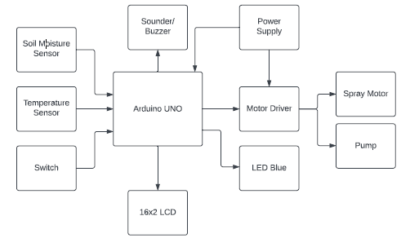
2.2 Hardware and Software Analysis

The hardware components we used in the project are:
- Arduino UNO
- Micro‐servo motor
- Soil Moisture Sensor (with screw terminals)
- LM 35 Temperature Sensor
- Jumper wires
- Speaker/Buzzer
- Breadboard
- USB‐A to B cables

For the software component we have used:
- Arduino IDE
- PROTEUS

2.3. Snapshots of Projects and Team Result:

Initial State:
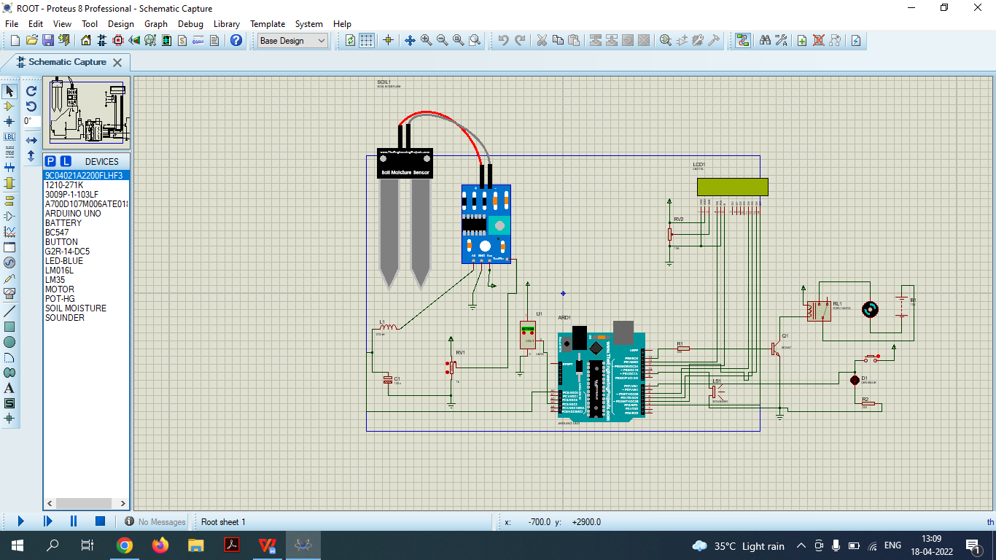

Active State:
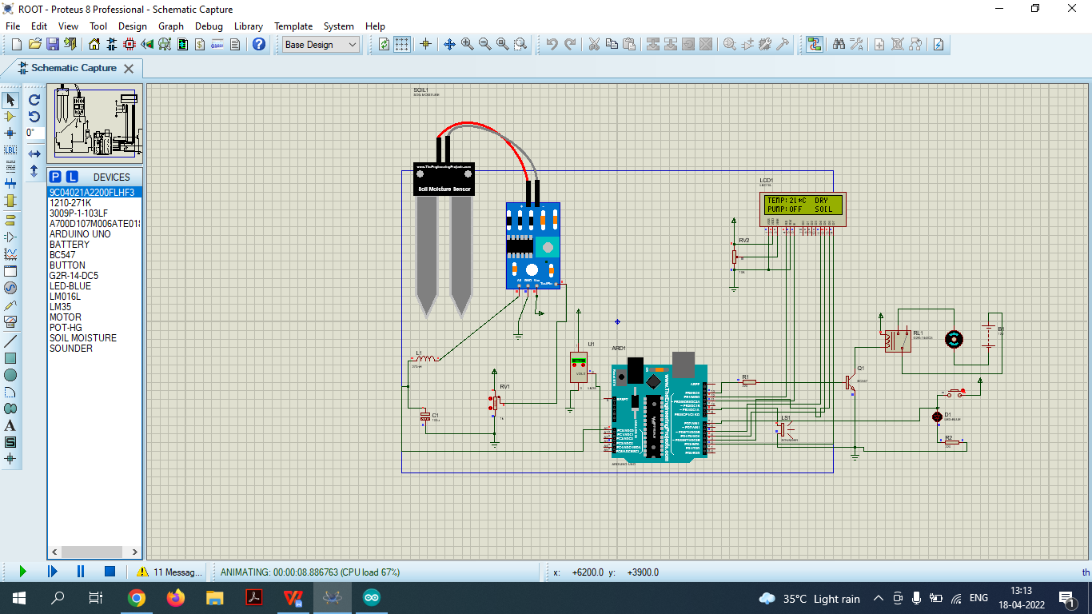

When soil is dry and pump is activated:
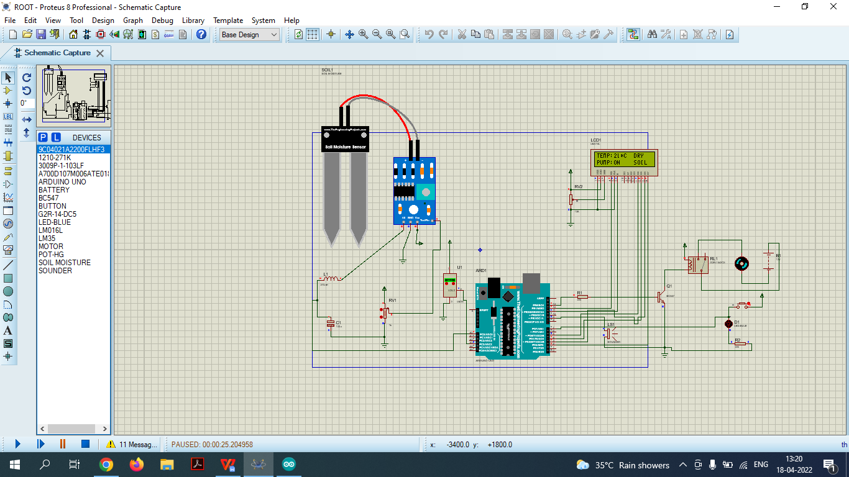

- SOFTWARE
3.1. Coding and Analysis:

Moisture Sensor:
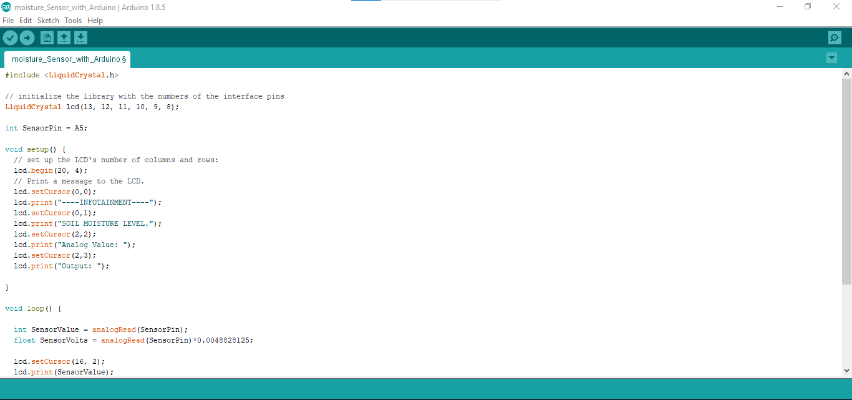

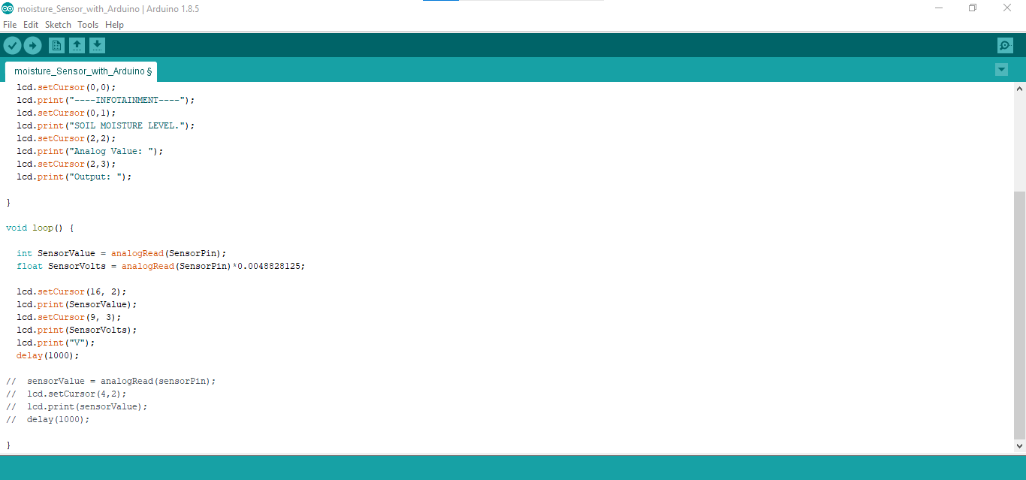

Arduino UNO Micro-controller:
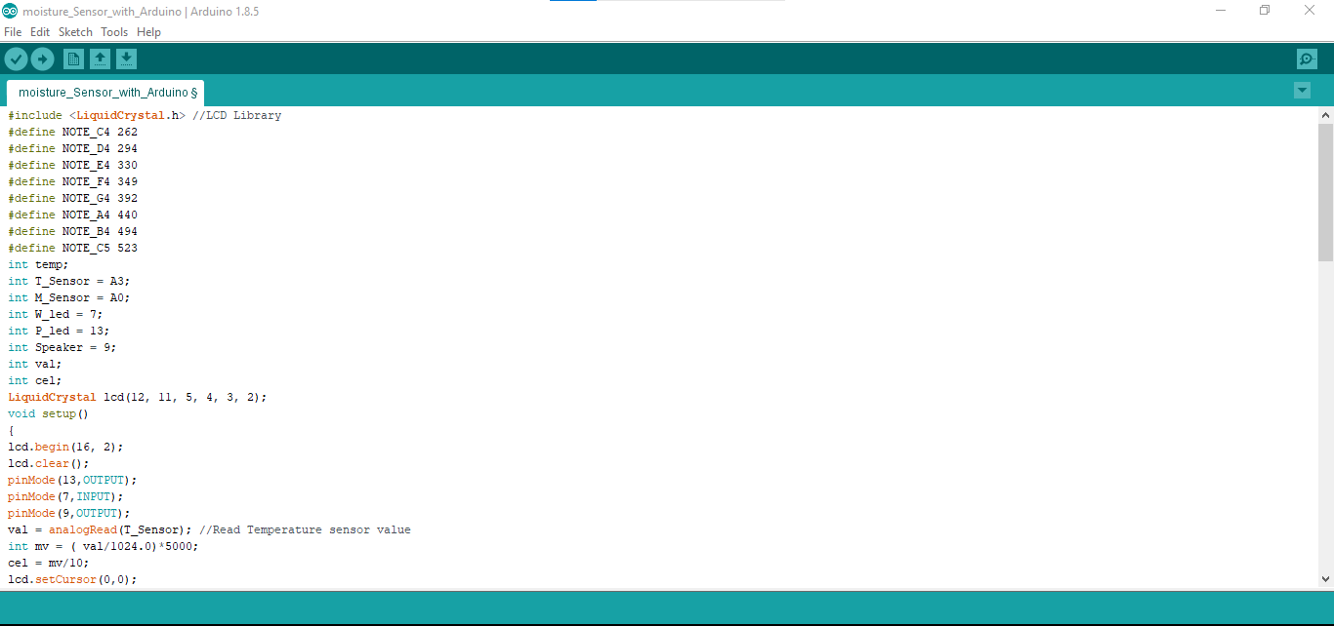
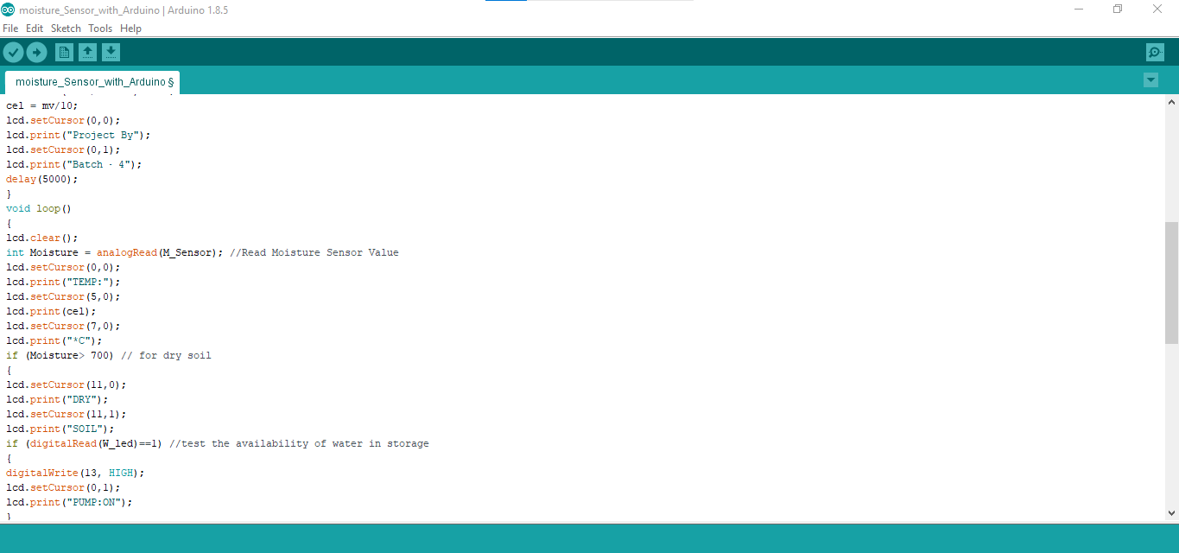

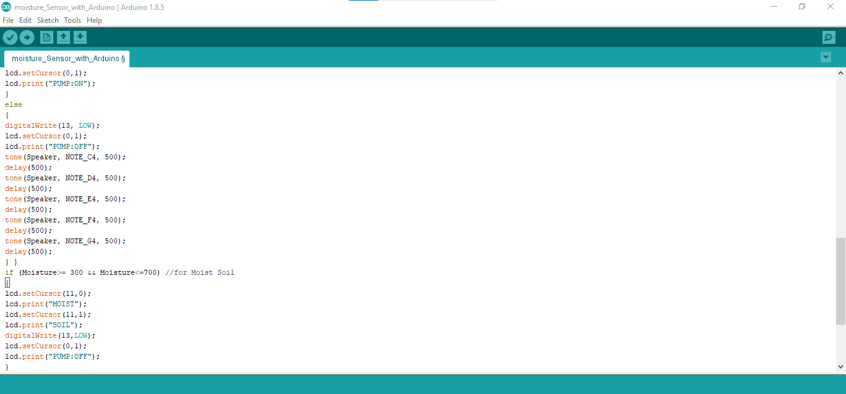

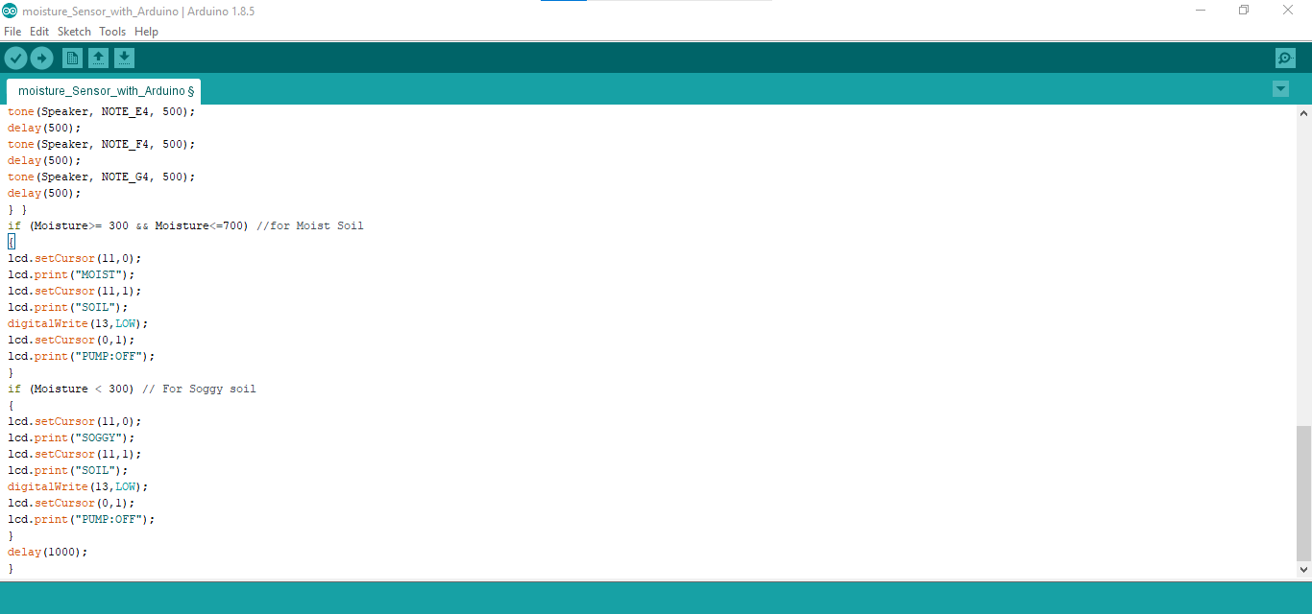

- Conclusion and Future Work

4.1. RESULT, CONCLUSION AND INFERENCE:

The Automatic Irrigation System is well-designed, taking into account all of the drawbacks of conventional systems. When compared to the existing systems for watering indoor plants that were detailed in the introduction section, our system design proved to be more portable.

The system is able to function perfectly in all aspects by staying true to our objectives and goals. The sensing is spot on, and water is being provided at the right moments.

We have concluded from this project that it is possible to create cost efficient systems which can cater to the most basic of human requirements. Our automatic irrigation system is the perfect example of this. This system has the capability to take care of all watering duties in any household.

Moreover we concluded that common decorative houseplants such as bamboo palms, money plant, snake plant, ficus benjamina, Chinese evergreen and spider plants not only make indoor spaces more attractive but also help to purify the air we breathe by absorbing toxins and acting as little oxygen factories.

Unfortunately, many plants die each year due to insufficient watering. We’ve all seen the brown, withered leaves about to fall off. Our system is the perfect solution to all this.

We have inferred from the success of this system that implementing the same idea and technology into a much larger system will expand the usability of the system and make it more attractive in the market. A much larger automatic irrigation system will be useful in larger areas like farms.

4.2. Future Work:

We have concluded that in the future solar panels can be used and integrated into the automatic irrigation system’s newer generations to eliminate the need of the 9V battery, making the entire system more reliable, efficient and self-sustainable with respect to energy consumption.

Having the system charge by itself (using the solar panels) will decrease the already decreased workload of the user making it more user-friendly than ever before.

In addition, we intend to improve the system's capacity to be managed remotely. This can be accomplished by using web-services to access and control the system (e.g. via Android smart-phones). This will also decrease the cost drastically.

The same web services can then be used for better planning and system failure avoidance, making the entire process more feasible.

We also plan on using present day temperature data and other required values to use artificial intelligence to our advantage and predict accurately the water requirements of the plant.

In short we plan on making this automatic irrigation system into the worlds smartest agricultural system which will ensure that no plant in its area ever dries out due to lack of adequate water, whatever the reason.

4.3. COST:

On comparing with other similar models our automatic irrigation system is significantly cost effective. The most basic version of automatic irrigation system requires only the most minimal of hardware requirements. Having no need of fancy technology, the cost is reduced drastically at this stage.

Moreover the software part doesn’t need cost. When the automatic irrigation system will be produced in large scale, software component will start demanding costs - software engineers will have to be hired. But since the original code is ours, this components cost is also reduced exponentially.

- References
- https://www.arduino.cc/en/Main/Software
- https://youtu.be/KWts8QZKIJw
- https://www.instructables.com/Automatic-Irrigation-System-for-Indoor-Gardening-U/

BIO DATA


Name: Saptajit Banerjee
Mobile Number: 9920100831
E-mail: saptajit.banerjee2020@vitstudent.in
Permanent Address: Mumbai


Name: Shilpan Pawan Singh
Mobile Number: 8805709351
E-mail: shilpanpawan.singh2020@vitstudent.ac.in
Permanent Address : Pune


Name: Ansh Goel
Mobile Number: 9667847401
E-mail: ansh.goel2020@vitstudent.ac.in
Permanent Address: Ghaziabad, UP

